

Complex Computing Activity

Department: Computer Science

Project Title: Shameel & Co. – Premium Sofa Sets Website
Course: ICT - Lab
Semester: First Semester

Submitted by | Muhammad Wahaj  (74742)
Submitted to | Muhammad Kamran

Shameel & Co. – Premium Sofa Sets Website

Title:
Shameel & Co. – Premium Sofa Sets Website
Introduction:
The system reduces manual workload and helps track business performance efficiently. This project is a responsive business website developed for Shameel & Co., a premium sofa manufacturing and furniture brand. The website is designed to showcase sofa collections, company information, featured products, and contact details in a modern and visually appealing manner. The purpose of this website is to provide an online presence for the business, attract customers, and present products professionally using modern web design techniques.

Project Objective:
The main objectives of this project are:
- Create a professional furniture business website
- Showcase premium sofa collections attractively
- Provide company information and brand identity
- Improve user experience with responsive design
- Display featured products with images and details
- Allow customers to easily contact the business
- Practice real-world front-end web development
Tools & Technologies:
- HTML5 – Structure of the website
- CSS3 – Styling and layout design
- JavaScript – Interactive behavior and navigation
- Google Fonts – Typography and branding
- Responsive Web Design – Mobile & desktop compatibility

System Overview:
The website consists of multiple structured sections and pages:

1. Home Page
- Hero section with brand introduction
- Navigation menu (Home, About, Collection, Blogs, Contact)
- Call-to-action buttons
- Featured sofa collections
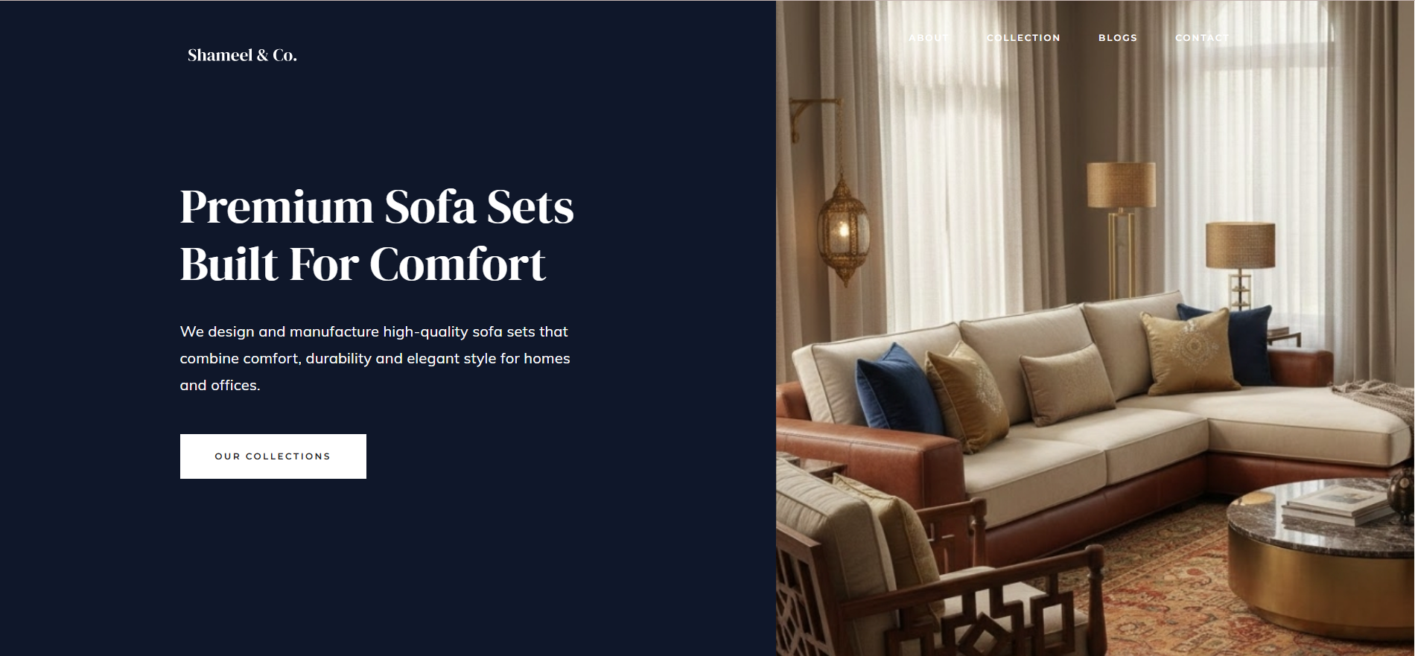

2. about Section
- Company introduction
- Brand philosophy
- Furniture quality and comfort information
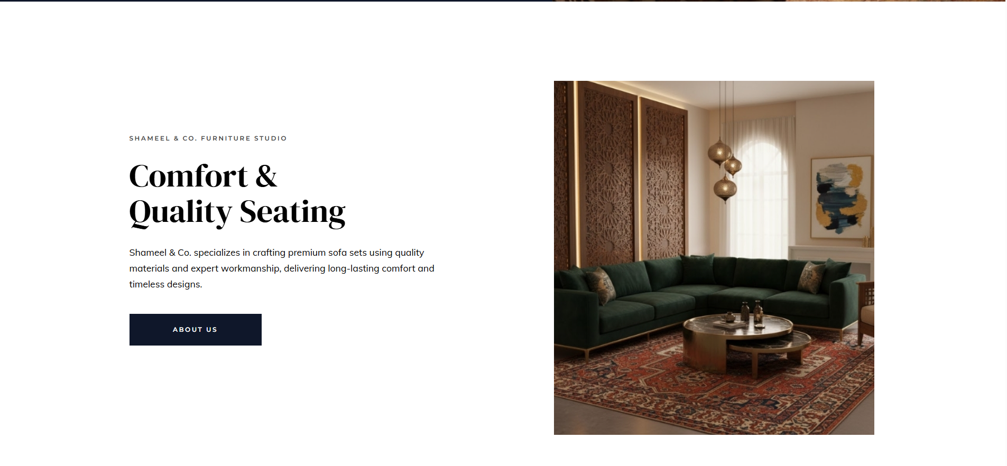

3. Services Section
- Custom sofa design
- Luxury sofa sets
- Fabric & leather sofas
- Home & office seating solutions
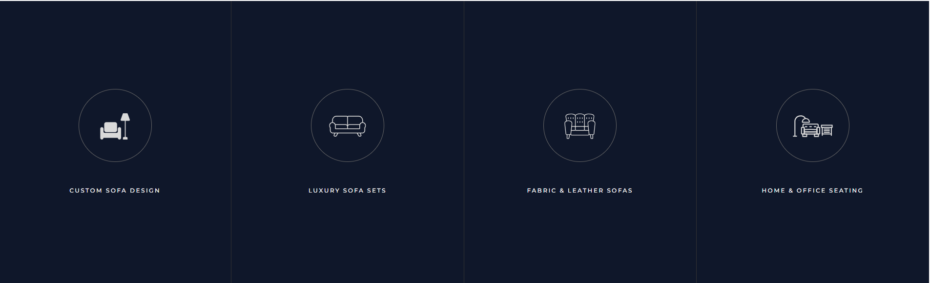

4. Featured Works / Collections
- Display of sofa designs
- Image gallery with overlay effects
- Product titles and categories
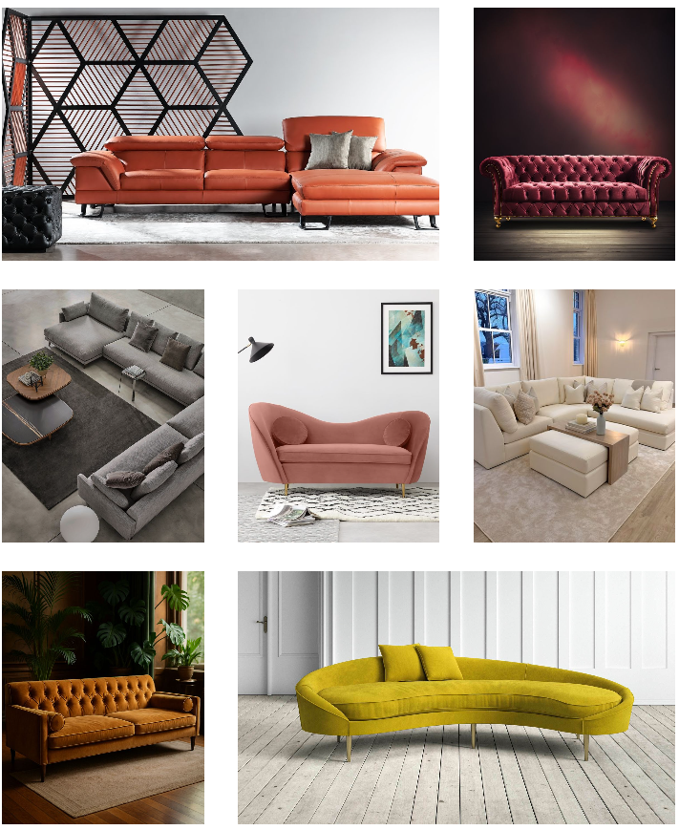

5. Contact Section
- Business contact information
- Email address
- Newsletter subscription form
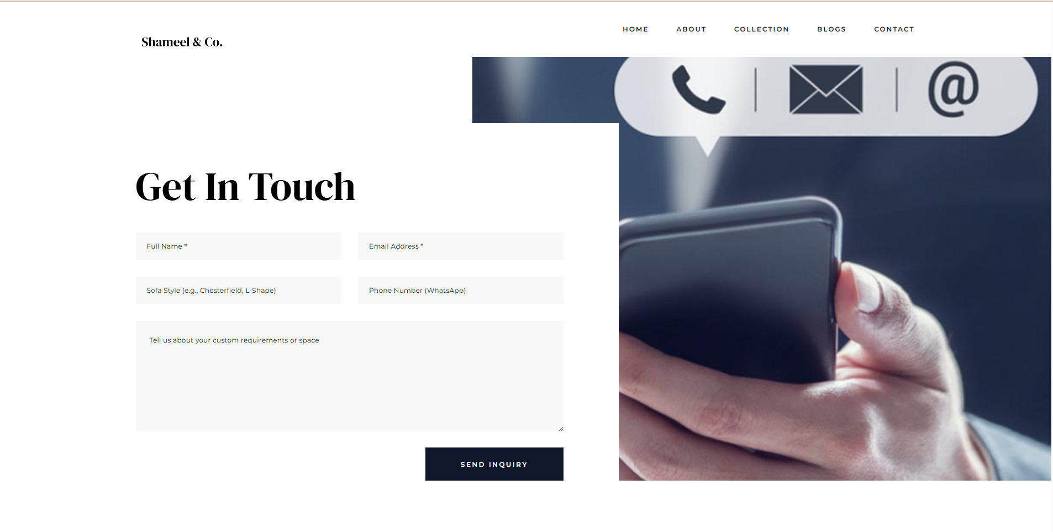

6. Footer Section
- Quick navigation links
- Social media links
- Contact details
- Copyright information
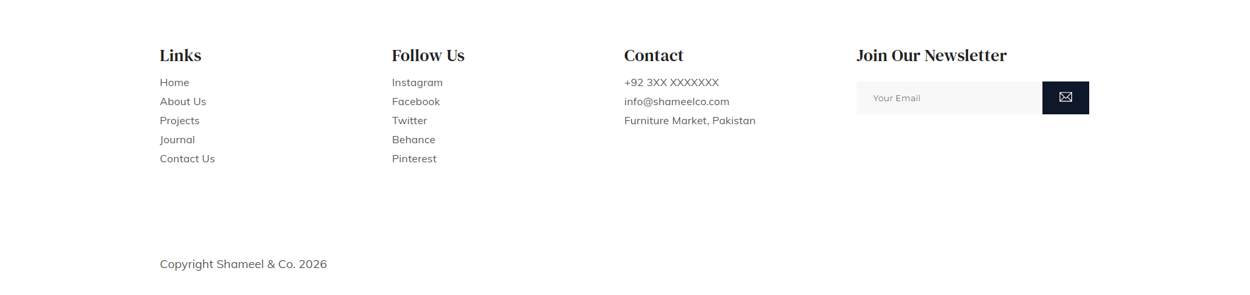

Website Features
- Clean and modern UI design
- Smooth navigation menu
- Image-based product showcase
- Mobile-friendly navigation
- SEO-friendly structure
- User-friendly interface
Home Page
The website is designed with a smooth, user-friendly flow that guides visitors naturally from discovery to action.
The journey begins with a strong hero section that immediately communicates the brand’s core offering—premium sofa sets built for comfort and quality. Clear messaging and a prominent call-to-action encourage users to explore the collections without distraction.
As users scroll, the About section builds trust by introducing Shameel & Co.’s craftsmanship, values, and expertise. This section reinforces brand credibility while keeping the experience visually engaging through balanced text and imagery.
Next, the Services section highlights key product categories in a concise and scannable format. Simple icons and short headings allow users to quickly understand what the brand offers, helping them identify their needs without cognitive overload.
The flow then transitions into the Featured Works section, where users explore real product examples. This visually rich gallery allows visitors to browse different sofa styles, materials, and use cases, reinforcing quality and design excellence while encouraging deeper engagement.

Towards the end, a strong contact call-to-action invites users to take the next step. Whether they are browsing for home or office seating, the message is clear and welcoming, reducing friction for inquiries.
Finally, the footer section provides supportive navigation, contact details, social links, and newsletter subscription, ensuring users always have access to important information without disrupting the main journey.
Overall, the website flow is intentional, linear, and conversion-focused, guiding users smoothly from brand introduction to exploration and contact, while maintaining a premium and professional experience throughout.
<!DOCTYPE html>
<html lang="en">

<head>
<meta charset="UTF-8">
<meta name="viewport" content="width=device-width, initial-scale=1.0, maximum-scale=1.0, user-scalable=0">
<title>Shameel &amp; Co. - Premium Sofa Sets</title>
<meta name="description"
content="Shameel & Co. – Premium quality sofa sets crafted for comfort, durability and modern living.">

<link rel="stylesheet" href="assets/css/main.css">

<link
href="https://fonts.googleapis.com/css?family=DM+Serif+Display%7CDM+Serif+Text%7CMontserrat:400,500,600%7CMuli:400,600,700&display=swap"
rel="stylesheet">

<link rel="icon" href="assets/img/favicon.png">
</head>

<body>

<main>
<div class="main-hero">

<header class="header">
<div class="container">

<a href="index.html">
<img src="assets/img/logo-white.svg" alt="Shameel Logo" class="logo">
</a>

<a href="#" class="open-nav open-nav-inverse"><i></i></a>

<nav class="navigation">
<ul>
<li><a href="about.html" style="color: white;">about</a></li>
<li><a href="collection.html" style="color: white;">collection</a></li>
<li><a href="blogs.html" style="color: white;">blogs</a></li>
<li><a href="contact.html" style="color: white;">contact</a></li>
</ul>
</nav>

<div class="clear"></div>
</div>
</header>

<div class="container">
<div class="block-1">
<div class="content">
<h1>premium sofa sets <br> built for comfort</h1>
<p>
We design and manufacture high-quality sofa sets that combine comfort,
durability and elegant style for homes and offices.
</p>
<a href="projects.html" class="btn-inverse">our collections</a>
</div>
</div>
</div>

<div class="main-hero-image"></div>
<div class="clear"></div>

</div>

<div class="about-us">
<div class="container">

<div class="block-1">
<div class="content">
<h3>shameel &amp; co. furniture studio</h3>
<h2>comfort &amp;<br> quality seating</h2>
<p>
Shameel &amp; Co. specializes in crafting premium sofa sets using quality materials
and expert workmanship, delivering long-lasting comfort and timeless designs.
</p>
<a href="about.html" class="btn">about us</a>
</div>
</div>

<div class="block-2">
<div class="about-image">
<img src="assets/img/about-image.jpg" alt="" class="img-cover">
</div>
</div>

<div class="clear"></div>
</div>
</div>

<div class="services">

<div class="item">
<div class="content">
<div class="icon">
<i><img src="assets/img/01_icon.svg" alt=""></i>
</div>
<h2>custom sofa design</h2>
</div>
</div>

<div class="item">
<div class="content">
<div class="icon">
<i><img src="assets/img/02_icon.svg" alt=""></i>
</div>
<h2>luxury sofa sets</h2>
</div>
</div>

<div class="item">
<div class="content">
<div class="icon">
<i><img src="assets/img/03_icon.svg" alt=""></i>
</div>
<h2>fabric &amp; leather sofas</h2>
</div>
</div>

<div class="item">
<div class="content">
<div class="icon">
<i><img src="assets/img/04_icon.svg" alt=""></i>
</div>
<h2>home &amp; office seating</h2>
</div>
</div>

<div class="clear"></div>
</div>

<div class="featured-works">
<div class="container">

<a href="case-study.html">
<div class="featured-works-item">
<img src="assets/img/image1.jpg" alt="" class="img-cover">
<div class="overlay">
<div class="content">
<span>sofa collection</span><span>2025</span>
<h2>royal comfort sofa</h2>
</div>
</div>
</div>
</a>

<a href="case-study.html">
<div class="featured-works-item">
<img src="assets/img/image2.jpg" alt="" class="img-cover">
<div class="overlay">
<div class="content">
<span>modern range</span><span>2025</span>
<h2>sectional sofa set</h2>
</div>
</div>
</div>
</a>

<a href="case-study.html">
<div class="featured-works-item">
<img src="assets/img/image3.jpg" alt="" class="img-cover">
<div class="overlay">
<div class="content">
<span>classic design</span><span>2025</span>
<h2>fabric lounge sofa</h2>
</div>
</div>
</div>
</a>

<a href="case-study.html">
<div class="featured-works-item">
<img src="assets/img/4.jpg" alt="" class="img-cover">
<div class="overlay">
<div class="content">
<span>premium</span><span>2025</span>
<h2>leather executive sofa</h2>
</div>
</div>
</div>
</a>

<a href="case-study.html">
<div class="featured-works-item">
<img src="assets/img/image5.jpg" alt="" class="img-cover">
<div class="overlay">
<div class="content">
<span>family living</span><span>2025</span>
<h2>family sofa set</h2>
</div>
</div>
</div>
</a>

<a href="case-study.html">
<div class="featured-works-item">
<img src="assets/img/image6.jpg" alt="" class="img-cover">
<div class="overlay">
<div class="content">
<span>office seating</span><span>2025</span>
<h2>corporate sofa</h2>
</div>
</div>
</div>
</a>

<a href="case-study.html">
<div class="featured-works-item">
<img src="assets/img/image7.jpg" alt="" class="img-cover">
<div class="overlay">
<div class="content">
<span>luxury range</span><span>2025</span>
<h2>designer sofa set</h2>
</div>
</div>
</div>
</a>

<div class="clear"></div>
</div>
</div>

<div class="contact-us">
<div class="block-1">
<div class="content">
<h2>Get in touch with us</h2>
<p>
If you are looking for premium sofa sets,
feel free to contact us and we will be happy to assist you.
</p>
<a href="contact.html" class="btn-inverse">contact us</a>
</div>
</div>

<div class="block-2"></div>
<div class="clear"></div>
</div>

</main>

<footer>
<div class="container">

<div class="footer-details">
<ul>
<li>links</li>
<li><a href="index.html">home</a></li>
<li><a href="about.html">about us</a></li>
<li><a href="projects.html">projects</a></li>
<li><a href="journal.html">journal</a></li>
<li><a href="contact.html">contact us</a></li>
</ul>
</div>

<div class="footer-details">
<ul>
<li>follow us</li>
<li><a href="#">instagram</a></li>
<li><a href="#">facebook</a></li>
<li><a href="#">twitter</a></li>
<li><a href="#">behance</a></li>
<li><a href="#">pinterest</a></li>
</ul>
</div>

<div class="footer-details">
<ul>
<li>contact</li>
<li>+92 3XX XXXXXXX</li>
<li class="footer-email">
<a href="mailto:info@shameelco.com" class="mail-link">info@shameelco.com</a>
</li>
<li>Furniture Market, Pakistan</li>
</ul>
</div>

<div class="footer-details">
<ul>
<li>join our newsletter</li>
<li>
<form class="subscribe-form" action="#">
<input type="email" placeholder="Your Email" required>
<button type="submit">
<img src="assets/img/email.svg" alt="">
</button>
</form>
<div class="clear"></div>
</li>
</ul>
</div>

<div class="clear"></div>

<p class="copyright">
copyright <i class="far fa-copyright"></i> shameel &amp; co. 2026
</p>

</div>
</footer>

<div class="responsive-nav-container">
<a href="#" class="close-nav"><i class="ti-close"></i></a>

<nav class="responsive-nav">
<ul>
<li><a href="index.html">home</a></li>
<li><a href="about.html">about</a></li>
<li><a href="collection.html">collection</a></li>
<li><a href="blogs.html">blogs</a></li>
<li><a href="contact.html">contact</a></li>
</ul>
</nav>

<ul class="social-links">
<li><a href="#">facebook</a></li>
<li><a href="#">twitter</a></li>
<li><a href="#">instagram</a></li>
<li><a href="#">behance</a></li>
</ul>
</div>

<script src="assets/js/main.js"></script>
</body>

</html>

About Page
- Company introduction
- Brand philosophy
- Furniture quality and comfort information
<!DOCTYPE html>
<html lang="en">

<head>
<meta charset="UTF-8">
<meta name="viewport" content="width=device-width, initial-scale=1.0, maximum-scale=1.0, user-scalable=0">
<title>About Us - Shameel &amp; Co. | Premium Sofa Manufacturers</title>
<meta name="description"
content="Learn about Shameel & Co. – our heritage of crafting premium, comfortable, and durable sofa sets for modern homes.">

<link rel="stylesheet" href="assets/css/main.css">

<link
href="https://fonts.googleapis.com/css?family=DM+Serif+Display%7CDM+Serif+Text%7CMontserrat:400,500,600%7CMuli:400,600,700&display=swap"
rel="stylesheet">

<link rel="icon" href="assets/img/favicon.png">
</head>

<body class="about-page">

<header class="header">
<div class="container">
<a href="index.html">
<img src="assets/img/logo.svg" alt="Shameel Logo" class="logo">
</a>

<a href="#" class="open-nav"><i></i></a>

<nav class="navigation">
<ul>
<li><a href="index.html">home</a></li>
<li><a href="about.html">about</a></li>
<li><a href="collection.html">collection</a></li>
<li><a href="blogs.html">blogs</a></li>
<li><a href="contact.html">contact</a></li>
</ul>
</nav>

<div class="clear"></div>
</div>
</header>

<main>
<div class="container">

<div class="info">
<header>
<h2>who we are</h2>
<h1>we are a premium<br> sofa manufacturing<br> & design studio</h1>
</header>

<div class="content">
<p>At Shameel & Co., we believe that a sofa is the heart of every home. Founded with a passion for
exceptional craftsmanship, we have dedicated ourselves to creating seating solutions that bridge
the gap between luxury and lasting durability. Our team of expert artisans combines traditional
techniques with modern ergonomics to ensure every piece is a masterpiece.</p>
<p>From selecting the finest seasoned hardwoods for our frames to sourcing premium upholstery
fabrics and high-resilience foams, we never compromise on quality. Our mission is to transform
your living space into a sanctuary of comfort.</p>
</div>

<div class="clear"></div>
</div>

<img src="assets/img/image10.webp" alt="Our Workshop" class="about-page-img img-cover">

<div class="info">
<header>
<h2>what we do</h2>
<h1>we craft bespoke &amp; <br> ergonomic seating</h1>
</header>

<div class="content">
<p>We specialize in the end-to-end creation of premium sofa sets, sectionals, and executive office
seating. Our design process is collaborative; we listen to your needs for space and style to
produce furniture that fits your life perfectly. Whether it is a minimalist modern lounge or a
grand classic set, we bring your vision to life.</p>
<p>Our commitment extends beyond delivery. We ensure that every stitch and every spring is placed
with precision, providing you with furniture that maintains its shape and comfort for years to
come. Experience the difference of artisanal furniture built specifically for you.</p>
</div>

<div class="clear"></div>
</div>

</div>

<div class="services">

<div class="item">
<div class="content">
<div class="icon">
<i><img src="assets/img/01_icon.svg" alt=""></i>
</div>
<h2>custom sofa design</h2>
</div>
</div>

<div class="item">
<div class="content">
<div class="icon">
<i><img src="assets/img/02_icon.svg" alt=""></i>
</div>
<h2>premium upholstery</h2>
</div>
</div>

<div class="item">
<div class="content">
<div class="icon">
<i><img src="assets/img/03_icon.svg" alt=""></i>
</div>
<h2>ergonomic engineering</h2>
</div>
</div>

<div class="item">
<div class="content">
<div class="icon">
<i><img src="assets/img/04_icon.svg" alt=""></i>
</div>
<h2>quality assurance</h2>
</div>
</div>

<div class="clear"></div>
</div>
</main>

<footer>
<div class="container">
<div class="footer-details">
<ul>
<li>links</li>
<li><a href="index.html">home</a></li>
<li><a href="about.html">about us</a></li>
<li><a href="projects.html">projects</a></li>
<li><a href="journal.html">journal</a></li>
<li><a href="contact.html">contact us</a></li>
</ul>
</div>

<div class="footer-details">
<ul>
<li>follow us</li>
<li><a href="#">instagram</a></li>
<li><a href="#">facebook</a></li>
<li><a href="#">twitter</a></li>
<li><a href="#">behance</a></li>
</ul>
</div>

<div class="footer-details">
<ul>
<li>contact</li>
<li>+92 3XX XXXXXXX</li>
<li class="footer-email"><a href="mailto:info@shameelco.com"
class="mail-link">info@shameelco.com</a></li>
<li>Furniture Market, Pakistan</li>
</ul>
</div>

<div class="footer-details">
<ul>
<li>join our newsletter</li>
<li>
<form class="subscribe-form" action="#">
<input type="email" placeholder="Your Email" required>
<button type="submit"><img src="assets/img/email.svg" alt=""></button>
</form>
<div class="clear"></div>
</li>
</ul>
</div>

<div class="clear"></div>
<p class="copyright">copyright <i class="far fa-copyright"></i> shameel &amp; co. 2026</p>
</div>
</footer>

<div class="responsive-nav-container">
<a href="#" class="close-nav"><i class="ti-close"></i></a>
<nav class="responsive-nav">
<ul>
<li><a href="index.html">home</a></li>
<li><a href="about.html">about</a></li>
<li><a href="collection.html">collection</a></li>
<li><a href="blogs.html">blogs</a></li>
<li><a href="contact.html">contact</a></li>
</ul>
</nav>
<ul class="social-links">
<li><a href="#">facebook</a></li>
<li><a href="#">twitter</a></li>
<li><a href="#">instagram</a></li>
<li><a href="#">behance</a></li>
</ul>
</div>

<script src="assets/js/main.js"></script>
</body>

</html>

Collection:
- Custom sofa design
- Luxury sofa sets
- Fabric & leather sofas
- Home & office seating solutions
<!DOCTYPE html>
<html lang="en">

<head>
<meta charset="UTF-8">
<meta name="viewport" content="width=device-width, initial-scale=1.0, maximum-scale=1.0, user-scalable=0">
<title>Shameel &amp; Co. - Premium Sofa Collections</title>
<meta name="description"
content="Explore Shameel & Co. premium sofa collections – from luxury leather to modern fabric sets.">

<link rel="stylesheet" href="assets/css/main.css">

<link
href="https://fonts.googleapis.com/css?family=DM+Serif+Display%7CDM+Serif+Text%7CMontserrat:400,500,600%7CMuli:400,600,700&display=swap"
rel="stylesheet">

<link rel="icon" href="assets/img/favicon.png">
</head>

<body class="projects-page">

<header class="header">

<div class="container">

<a href="index.html">
<img src="assets/img/logo.svg" alt="Shameel Logo" class="logo">
</a>

<a href="#" class="open-nav"><i></i></a>

<nav class="navigation">

<ul>
<li><a href="index.html">home</a></li>
<li><a href="about.html">about</a></li>
<li><a href="collection.html">collection</a></li>
<li><a href="blogs.html">blogs</a></li>
<li><a href="contact.html">contact</a></li>
</ul>

</nav>
<div class="clear"></div>

</div>
</header>
<main>

<div class="container">

<div class="projects">

<a href="collection-inside.html">

<div class="item">
<img src="assets/img/C-01.jpg" alt="" class="img-cover">
<h2><span>01</span>luxury leather</h2>
</div>

</a>

<a href="collection-inside.html">

<div class="item">
<img src="assets/img/C-02.jpg" alt="" class="img-cover">
<h2><span>02</span>modern fabric</h2>
</div>

</a>

<a href="collection-inside.html">

<div class="item">
<img src="assets/img/C-03.jpg" alt="" class="img-cover">
<h2><span>03</span>l-shaped sectionals</h2>
</div>

</a>

<a href="collection-inside.html">

<div class="item">
<img src="assets/img/C-04.webp" alt="" class="img-cover">
<h2><span>04</span>executive office</h2>
</div>

</a>

<div class="clear"></div>

</div>
</div>
</main>
<footer>

<div class="container">

<div class="footer-details">
<ul>
<li>links</li>
<li><a href="index.html">home</a></li>
<li><a href="about.html">about us</a></li>
<li><a href="projects.html">projects</a></li>
<li><a href="journal.html">journal</a></li>
<li><a href="contact.html">contact us</a></li>
</ul>
</div>

<div class="footer-details">
<ul>
<li>follow us</li>
<li><a href="#">instagram</a></li>
<li><a href="#">facebook</a></li>
<li><a href="#">twitter</a></li>
<li><a href="#">behance</a></li>
<li><a href="#">pinterest</a></li>
</ul>
</div>

<div class="footer-details">
<ul>
<li>contact</li>
<li>+92 3XX XXXXXXX</li>
<li class="footer-email"><a href="mailto:info@shameelco.com"
class="mail-link">info@shameelco.com</a></li>
<li>Furniture Market, Pakistan</li>
</ul>
</div>

<div class="footer-details">
<ul>
<li>join our newsletter</li>
<li>
<form class="subscribe-form" action="#">
<input type="email" placeholder="Your Email" required>
<button type="submit"><img src="assets/img/email.svg" alt=""></button>
</form>
<div class="clear"></div>
</li>
</ul>
</div>

<div class="clear"></div>

<p class="copyright">copyright <i class="far fa-copyright"></i> shameel &amp; co. 2026</p>

</div>
</footer>
<div class="responsive-nav-container">

<a href="#" class="close-nav"><i class="ti-close"></i></a>

<nav class="responsive-nav">

<ul>
<li><a href="index.html">home</a></li>
<li><a href="about.html">about</a></li>
<li><a href="projects.html">projects</a></li>
<li><a href="journal.html">journal</a></li>
<li><a href="contact.html">contact</a></li>
</ul>

</nav>
<ul class="social-links">
<li><a href="#">facebook</a></li>
<li><a href="#">twitter</a></li>
<li><a href="#">instagram</a></li>
<li><a href="#">behance</a></li>
</ul>

</div>
<script src="assets/js/main.js"></script>
</body>

</html>
Blog Page
<!DOCTYPE html>
<html lang="en">

<head>
<meta charset="UTF-8">
<meta name="viewport" content="width=device-width, initial-scale=1.0, maximum-scale=1.0, user-scalable=0">
<title>Blogs - Shameel &amp; Co. | Sofa Care & Design Trends</title>
<meta name="description"
content="Expert advice on sofa maintenance, fabric selection, and modern living room styling from Shameel & Co.">

<link rel="stylesheet" href="assets/css/main.css">

<link
href="https://fonts.googleapis.com/css?family=DM+Serif+Display%7CDM+Serif+Text%7CMontserrat:400,500,600%7CMuli:400,600,700&display=swap"
rel="stylesheet">

<link rel="icon" href="assets/img/favicon.png">
</head>

<body class="journal">

<header class="header">

<div class="container-large">

<a href="index.html">
<img src="assets/img/logo-white.svg" alt="Shameel Logo" class="logo">
</a>

<a href="#" class="open-nav open-nav-inverse"><i></i></a>

<nav class="navigation">

<ul>
<li><a href="index.html">home</a></li>
<li><a href="about.html">about</a></li>
<li><a href="collection.html">collection</a></li>
<li><a href="blogs.html">blogs</a></li>
<li><a href="contact.html">contact</a></li>
</ul>

</nav>
<div class="clear"></div>

</div>
</header>
<main>

<div class="entries-list">

<div class="entry">
<a href="#" class="entry-category">maintenance</a>
<h1 data-entry-link="post-1" class="entry-title"><a href="single-journal-entry.html" class="active">how
to clean and maintain your leather sofa</a></h1>
</div>
<div class="entry">
<a href="#" class="entry-category">guide</a>
<h1 data-entry-link="post-2" class="entry-title"><a href="single-journal-entry.html">choosing the right
fabric for high-traffic homes</a></h1>
</div>
<div class="entry">
<a href="#" class="entry-category">trends</a>
<h1 data-entry-link="post-3" class="entry-title"><a href="single-journal-entry.html">modern seating
trends: top sofa styles for 2026</a></h1>
</div>
<div class="entry">
<a href="#" class="entry-category">craftsmanship</a>
<h1 data-entry-link="post-4" class="entry-title"><a href="single-journal-entry.html">why kiln-dried
hardwood frames last a lifetime</a></h1>
</div>
<div class="entry">
<a href="#" class="entry-category">styling</a>
<h1 data-entry-link="post-5" class="entry-title"><a href="single-journal-entry.html">how to style your
sectional for a cozy winter</a></h1>
</div>
</div>
<div class="entry-thumbs">

<div data-entry-thumb="post-1" class="entry-thumb active">
<img src="assets/img/b1.jpg" alt="" class="img-cover">
</div>

<div data-entry-thumb="post-2" class="entry-thumb">
<img src="assets/img/b2.jpg" alt="" class="img-cover">
</div>

<div data-entry-thumb="post-3" class="entry-thumb">
<img src="assets/img/b3.jpg" alt="" class="img-cover">
</div>

<div data-entry-thumb="post-4" class="entry-thumb">
<img src="assets/img/b4.jpg" alt="" class="img-cover">
</div>

<div data-entry-thumb="post-5" class="entry-thumb">
<img src="assets/img/b5.jpg" alt="" class="img-cover">
</div>

</div>
</main>
<footer>

<div class="container">

<div class="footer-details">
<ul>
<li>links</li>
<li><a href="index.html">home</a></li>
<li><a href="about.html">about us</a></li>
<li><a href="projects.html">projects</a></li>
<li><a href="journal.html">journal</a></li>
<li><a href="contact.html">contact us</a></li>
</ul>
</div>

<div class="footer-details">
<ul>
<li>follow us</li>
<li><a href="#">instagram</a></li>
<li><a href="#">facebook</a></li>
<li><a href="#">twitter</a></li>
<li><a href="#">behance</a></li>
<li><a href="#">pinterest</a></li>
</ul>
</div>

<div class="footer-details">
<ul>
<li>contact</li>
<li>+92 3XX XXXXXXX</li>
<li class="footer-email"><a href="mailto:info@shameelco.com"
class="mail-link">info@shameelco.com</a></li>
<li>Furniture Market, Pakistan</li>
</ul>
</div>

<div class="footer-details">
<ul>
<li>join our newsletter</li>
<li>
<form class="subscribe-form" action="#">
<input type="email" placeholder="Your Email" required>
<button type="submit"><img src="assets/img/email.svg" alt=""></button>
</form>
<div class="clear"></div>
</li>
</ul>
</div>

<div class="clear"></div>

<p class="copyright">copyright <i class="far fa-copyright"></i> shameel &amp; co. 2026</p>

</div>
</footer>
<div class="responsive-nav-container">

<a href="#" class="close-nav"><i class="ti-close"></i></a>

<nav class="responsive-nav">

<ul>
<li><a href="index.html">home</a></li>
<li><a href="about.html">about</a></li>
<li><a href="collection.html">collection</a></li>
<li><a href="blogs.html">blogs</a></li>
<li><a href="contact.html">contact</a></li>
</ul>

</nav>
<ul class="social-links">
<li><a href="#">facebook</a></li>
<li><a href="#">twitter</a></li>
<li><a href="#">instagram</a></li>
<li><a href="#">behance</a></li>
</ul>

</div>
<script src="assets/js/main.js"></script>
</body>

</html>
Contact Us Page
- Business contact information
- Email address
- Newsletter subscription form
<!DOCTYPE html>
<html lang="en">

<head>
<meta charset="UTF-8">
<meta name="viewport" content="width=device-width, initial-scale=1.0, maximum-scale=1.0, user-scalable=0">
<title>Contact Us - Shameel &amp; Co.</title>
<meta name="description"
content="Get in touch with Shameel & Co. for custom sofa inquiries and premium furniture consultations.">

<link rel="stylesheet" href="assets/css/main.css">

<link
href="https://fonts.googleapis.com/css?family=DM+Serif+Display%7CDM+Serif+Text%7CMontserrat:400,500,600%7CMuli:400,600,700&display=swap"
rel="stylesheet">

<link rel="icon" href="assets/img/favicon.png">
</head>

<body>

<header class="header">

<div class="container">

<a href="index.html">
<img src="assets/img/logo.svg" alt="Shameel Logo" class="logo">
</a>

<a href="#" class="open-nav"><i></i></a>

<nav class="navigation">

<ul>
<li><a href="index.html">home</a></li>
<li><a href="about.html">about</a></li>
<li><a href="collection.html">collection</a></li>
<li><a href="blogs.html">blogs</a></li>
<li><a href="contact.html">contact</a></li>
</ul>

</nav>
<div class="clear"></div>

</div>
</header>
<main class="contact">

<div class="contact-image"></div>

<div class="container">

<div class="contact-form-container">

<h1>get in touch</h1>

<form action="#" class="contact-form">

<input name="name" placeholder="Full Name *" type="text" required>
<input name="email" placeholder="Email Address *" type="email" required>
<input name="project-type" placeholder="Sofa Style (e.g., Chesterfield, L-Shape)" type="text">
<input name="phone-number" placeholder="Phone Number (WhatsApp)" type="tel">
<textarea name="message" placeholder="Tell us about your custom requirements or space"
required></textarea>
<input type="submit" value="send inquiry" class="btn">
<div class="clear"></div>

</form>
</div>

</div>
<div class="clear"></div>

</main>
<footer>

<div class="container">

<div class="footer-details">
<ul>
<li>links</li>
<li><a href="index.html">home</a></li>
<li><a href="about.html">about us</a></li>
<li><a href="projects.html">projects</a></li>
<li><a href="journal.html">journal</a></li>
<li><a href="contact.html">contact us</a></li>
</ul>
</div>

<div class="footer-details">
<ul>
<li>follow us</li>
<li><a href="#">instagram</a></li>
<li><a href="#">facebook</a></li>
<li><a href="#">twitter</a></li>
<li><a href="#">behance</a></li>
<li><a href="#">pinterest</a></li>
</ul>
</div>

<div class="footer-details">
<ul>
<li>contact</li>
<li>+92 3XX XXXXXXX</li>
<li class="footer-email"><a href="mailto:info@shameelco.com"
class="mail-link">info@shameelco.com</a></li>
<li>Furniture Market, Pakistan</li>
</ul>
</div>

<div class="footer-details">
<ul>
<li>join our newsletter</li>
<li>
<form class="subscribe-form" action="#">
<input type="email" placeholder="Your Email" required>
<button type="submit"><img src="assets/img/email.svg" alt=""></button>
</form>
<div class="clear"></div>
</li>
</ul>
</div>

<div class="clear"></div>

<p class="copyright">copyright <i class="far fa-copyright"></i> shameel &amp; co. 2026</p>

</div>
</footer>
<div class="responsive-nav-container">

<a href="#" class="close-nav"><i class="ti-close"></i></a>

<nav class="responsive-nav">

<ul>
<li><a href="index.html">home</a></li>
<li><a href="about.html">about</a></li>
<li><a href="collection.html">collection</a></li>
<li><a href="blogs.html">blogs</a></li>
<li><a href="contact.html">contact</a></li>
</ul>

</nav>
<ul class="social-links">
<li><a href="#">facebook</a></li>
<li><a href="#">twitter</a></li>
<li><a href="#">instagram</a></li>
<li><a href="#">behance</a></li>
</ul>

</div>
<script src="assets/js/main.js"></script>
</body>

</html>

Style Sheet
/*-----------------------------------------------------
# color #222
------------------------------------------------------*/
/* Brand Primary */
.navigation a,
.footer-details li:first-child,
.entry-author,
.project-category .item h2,
.featured-works-item .overlay .content,
.btn-inverse,
.projects a,
.entry-category,
.quote,
.contact-form input::placeholder,
.contact-form textarea::placeholder {
color: #222;
}

/*-----------------------------------------------------
# background #0F172A
------------------------------------------------------*/

.open-nav i,
.open-nav i:before,
.open-nav i:after,
.case-study .hero .content h2:before,
.featured-works-item .overlay .content span:nth-of-type(2):after,
.responsive-nav-container,
.footer-details form button:hover,
.similar-posts,
.journal,
.next-project header,
.btn:hover,
.main-hero,
.contact-us .block-1,
.btn,
.footer-details form button,
.contact-form textarea::-webkit-scrollbar-thumb,
.services .item,
.projects .item span:after {
background: #0F172A;
}

.similar-posts .item .overlay {
background: rgba(0, 0, 0, .7);
}

/*-----------------------------------------------------
# color #444
------------------------------------------------------*/

.about-us .content h3 {
color: #444;
}

/*-----------------------------------------------------
# color #555
------------------------------------------------------*/

.copyright,
.footer-details li,
.footer-details li a {
color: #555;
}

/*-----------------------------------------------------
# color #666
------------------------------------------------------*/

.entry-date,
.entry-image_1 figcaption {
color: #666;
}

/*-----------------------------------------------------
# color #fff
------------------------------------------------------*/

.responsive-nav-container a,
.footer-details .ti-email,
.similar-posts header,
.similar-posts .item .overlay a,
.services .item .content h2,
.entry-title a,
.navigation-inverse a,
.next-project header,
.btn,
.main-hero .block-1,
.contact-us .block-1 .content,
.entries-list .entry-category {
color: #fff;
}

/*-----------------------------------------------------
# background #fff
------------------------------------------------------*/

footer,
.entry-header,
.open-nav-inverse i,
.open-nav-inverse i:before,
.open-nav-inverse i:after,
.contact-form-container,
.main-hero .btn:hover,
.contact-us .btn:hover,
.btn-inverse {
background: #fff;
}

.featured-works-item .overlay {
background: rgba(255, 255, 255, .8);
}

/*-----------------------------------------------------
# background #f8f8f8
------------------------------------------------------*/

form input,
form textarea,
.case-study .details,
.quote {
background: #f8f8f8;
}

/*-----------------------------------------------------
General Styles
------------------------------------------------------*/

* {
box-sizing: border-box;
margin: 0;
padding: 0;
}

html {
overflow-x: hidden;
overflow-y: scroll;
}

body {
font-family: Muli, sans-serif;
font-size: 100%;
line-height: 1.5;
-webkit-font-smoothing: antialiased;
}

a {
text-decoration: none;
transition: all .2s ease-in-out;
}

.btn,
.btn-inverse {
align-items: center;
display: flex;
font-family: Montserrat, sans-serif;
font-size: .75rem;
font-weight: 600;
height: 60px;
letter-spacing: 2.5px;
justify-content: center;
text-transform: uppercase;
width: 250px;
}

.container {
max-width: 1410px;
margin: auto;
}

.container-large {
max-width: 1720px;
margin: auto;
}

.clear {
clear: both;
}

.img-cover {
background: lightslategray;
display: block;
object-fit: cover;
height: 100%;
width: 100%;
}

.img-responsive {
display: block;
max-width: 100%;
height: auto;
}

/*-----------------------------------------------------
2. Navigation
------------------------------------------------------*/

.header {
height: 100px;
line-height: 100px;
width: 100%;
}

.logo {
height: 80px;
margin-top: 36px;
}

.navigation {
float: right;
}

.navigation li {
float: left;
font-family: Montserrat, sans-serif;
font-size: .75rem;
font-weight: 600;
letter-spacing: 2px;
list-style: none;
margin-left: 50px;
text-transform: uppercase;
}

.open-nav {
display: none;
float: right;
height: 22px;
margin: 38px 0;
position: relative;
width: 28px;
}

.open-nav:hover {
cursor: pointer;
}

.open-nav i {
position: absolute;
top: 50%;
right: 0;
height: 2px;
width: 100%;
transition: all .3s ease-in-out;
}

.open-nav i:before {
position: absolute;
top: -9px;
content: " ";
height: 2px;
width: 100%;
transition: all .3s ease-in-out;
}

.open-nav i:after {
position: absolute;
top: 9px;
content: " ";
height: 2px;
width: 100%;
transition: all .3s ease-in-out;
}

.open-nav:hover i:before,
.open-nav:hover i:after {
width: 80%;
}

.responsive-nav-container {
position: fixed;
top: 0;
left: -100%;
bottom: 0;
right: 0;
height: 100vh;
width: 100vw;
opacity: 0;
transition: opacity .4s, left 0s .4s;
z-index: 2;
}

.responsive-nav-container.active {
left: 0;
opacity: 1;
transition: opacity .4s, left 0s;
}

.close-nav {
font-size: 1.5rem;
position: absolute;
right: 70px;
top: 35px;
}

.responsive-nav {
left: 70px;
position: absolute;
top: 50%;
transform: translateY(-50%);
}

.responsive-nav li {
font-family: 'DM Serif Display', serif;
font-size: 2.7rem;
letter-spacing: 1px;
list-style: none;
margin-bottom: 8px;
position: relative;
text-transform: capitalize;
}

.social-links {
bottom: 35px;
left: 70px;
position: absolute;
}

.social-links li {
float: left;
font-family: Montserrat, sans-serif;
font-size: .6875rem;
font-weight: 500;
letter-spacing: 3px;
list-style: none;
margin-right: 50px;
text-transform: uppercase;
}

/*-----------------------------------------------------
3. Footer
------------------------------------------------------*/

footer {
padding-top: 100px;
}

.footer-details {
float: left;
width: 25%;
}

.footer-details li {
letter-spacing: .2px;
list-style: none;
margin-bottom: 5px;
text-transform: capitalize;
}

.footer-details li:first-child {
font-family: 'DM Serif Text', sans-serif;
font-size: 1.625rem;
margin-bottom: 9px;
}

.footer-details .footer-email {
text-transform: lowercase;
}

.footer-details:nth-of-type(4) li:first-child {
margin-bottom: 20px;
}

.footer-details form input {
border: none;
float: left;
font-family: Montserrat, sans-serif;
height: 50px;
outline: none;
padding-left: 25px;
width: 80%;
}

.footer-details form input::placeholder {
font-family: Montserrat, sans-serif;
}

.footer-details form button {
border: none;
cursor: pointer;
float: left;
height: 50px;
transition: all .2s ease-in-out;
width: 20%;
}

.footer-details form button img {
width: 27%;
}

.copyright {
font-size: 1.125rem;
padding: 130px 0 43px 0;
text-transform: capitalize;
}

/*-----------------------------------------------------
4. Pages
------------------------------------------------------*/

/* =============== # About Us =============== */

.about-page .info {
margin: 145px 0 140px 0;
}

.about-page .info h2 {
font-family: Montserrat, sans-serif;
font-size: .75rem;
font-weight: 500;
letter-spacing: 2.5px;
margin-bottom: 20px;
text-transform: uppercase;
}

.about-page .info h1 {
font-family: 'DM Serif Text', serif;
font-size: 3rem;
font-weight: 400;
line-height: 1.2;
text-transform: capitalize;
}

.about-page .info header,
.about-page .info .content {
float: left;
width: 48%;
}

.about-page .info .content {
margin-top: 50px;
margin-left: 4%;
}

.about-page .info p {
font-size: 1.1rem;
line-height: 1.7;
}

.about-page .info p:nth-of-type(1) {
margin-bottom: 18px;
}

.about-page-img {
height: 600px;
width: 100%;
}

/* =============== # Case Study =============== */

.case-study .hero {
height: 700px;
width: 100%;
}

.case-study .hero .img-placeholder {
background: url('https://i.ytimg.com/vi/KR7QX57f0E0/maxresdefault.jpg');
-webkit-background-size: cover;
background-size: cover;
background-position: right;
height: 700px;
left: 0;
position: absolute;
top: 100px;
width: 63%;
z-index: -999;
}

.case-study .hero .content {
float: right;
padding-top: 200px;
width: 44%;
}

.case-study .hero .content h2 {
font-family: Montserrat, sans-serif;
font-size: .75rem;
font-weight: 500;
letter-spacing: 2.5px;
margin-left: 12%;
padding-left: 100px;
position: relative;
text-transform: uppercase;
}

.case-study .hero .content h2:before {
content: '';
height: 1px;
left: 0;
position: absolute;
top: 8px;
width: 70px;
}

.case-study .hero .content h1 {
font-family: 'DM Serif Display', serif;
font-size: 5.5rem;
font-weight: 400;
line-height: .9;
margin: 33px 0 38px 0;
text-transform: capitalize;
}

.case-study .hero .content p {
font-size: 1.2rem;
line-height: 1.6;
margin-left: 30%;
}

.case-study .info {
float: left;
margin: 137px 0 140px 8.5%;
width: 50%;
}

.case-study .info p:first-child {
font-size: 1.3rem;
font-weight: 700;
margin-bottom: 20px;
}

.case-study .info p {
font-size: 1.2rem;
line-height: 1.7;
}

.case-study .info-2 {
font-size: 1.375rem;
line-height: 1.7;
letter-spacing: .2px;
margin: 106px auto;
text-align: center;
width: 65%;
}

.case-study .details {
float: right;
margin-top: 150px;
padding: 32px 0 40px 0;
width: 26%;
}

.case-study .details li {
float: left;
font-family: 'DM Serif Text', serif;
font-size: 1.375rem;
font-weight: 400;
list-style: none;
padding: 0 0 0 45px;
text-transform: capitalize;
width: 50%;
}

.case-study .details li:nth-of-type(even) {
padding: 0 0 0 30px;
}

.case-study .details li:nth-of-type(1),
.case-study .details li:nth-of-type(2) {
margin-bottom: 18px;
}

.case-study .details li span {
display: block;
font-family: Montserrat, sans-serif;
font-size: .6875rem;
letter-spacing: 1.5px;
margin-top: 6px;
margin-top: 3px;
text-transform: uppercase;
}

.case-study .details li:nth-of-type(2) span {
margin-top: 0.5px;
}

.case-study .details .small-letter {
display: inline-block;
text-transform: lowercase;
}

.case-study-image_1 {
height: 700px;
margin-bottom: 60px;
width: 100%;
}

.case-study-image_2,
.case-study-image_3,
.case-study-image_4,
.case-study-image_5 {
float: left;
height: 700px;
width: 48%;
}

.case-study-image_2,
.case-study-image_4 {
margin-right: 4%;
}

.next-project {
margin-top: 150px;
}

.next-project header {
align-items: center;
display: flex;
float: left;
height: 450px;
justify-content: center;
width: 33%;
}

.next-project header h2 {
font-family: 'DM Serif Display', serif;
font-size: 4.2rem;
font-weight: 400;
line-height: 1.2;
text-transform: capitalize;
}

.next-project .thumbnail {
float: left;
height: 450px;
width: 67%;
}

/* =============== # Contact =============== */

.contact-image {
background: url('..//img/contact-image.jpg');
background-position: right;
-webkit-background-size: cover;
background-size: cover;
height: 767px;
float: right;
width: 55%;
}

.contact .container {
position: relative;
}

.contact-form-container {
height: 647px;
padding: 60px 100px 0 0;
position: absolute;
top: 120px;
width: 62%;
}

.contact-form-container h1 {
font-family: 'DM Serif Display', serif;
font-size: 4.5rem;
font-weight: 400;
padding-bottom: 30px;
text-transform: capitalize;
}

.contact-form input,
.contact-form textarea {
border: none;
outline: none;
}

.contact-form input {
margin-bottom: 30px;
}

.contact-form input::placeholder,
.contact-form input,
.contact-form textarea::placeholder {
font-family: Montserrat, sans-serif;
font-size: .75rem;
letter-spacing: .3px;
}

.contact-form input[name=name],
.contact-form input[name=email],
.contact-form input[name=project-type],
.contact-form input[name=phone-number] {
float: left;
height: 50px;
line-height: 50px;
padding-left: 20px;
width: 48%;
}

.contact-form input[name=name],
.contact-form input[name=project-type] {
margin-right: 4%;
}

.contact-form textarea {
height: 200px;
padding: 25px;
width: 100%;
}

.contact-form textarea {
font-family: Montserrat, sans-serif;
font-size: .875rem;
line-height: 1.6;
}

.contact-form textarea::-webkit-scrollbar {
width: 8px;
}

.contact-form input[type=submit] {
cursor: pointer;
float: right;
letter-spacing: 2.5px;
margin-top: 23px;
transition: all .2s linear;
}

/* =============== # Homepage =============== */

/* =============== = About us =============== */

.about-us {
margin: 150px 0;
}

.about-us .block-1 {
float: left;
width: 57%;
}

.about-us .block-2 {
float: left;
width: 43%;
}

.about-us .block-1 {
margin-top: 100px;
}

.about-us .block-2 .about-image {
height: 670px;
}

.about-us .content h3 {
font-family: Montserrat, sans-serif;
font-size: .75rem;
font-weight: 600;
letter-spacing: 2.5px;
text-transform: uppercase;
}

.about-us .content h2 {
font-family: 'DM Serif Display', serif;
font-size: 3.8rem;
font-weight: 400;
line-height: 1.1;
margin: 28px 0 30px 0;
text-transform: capitalize;
}

.about-us .content p {
font-size: 1.1rem;
line-height: 1.7;
margin-bottom: 42px;
width: 73%;
}

/* =============== = Contact Us =============== */

.contact-us .block-1 {
align-items: center;
display: flex;
float: left;
height: 680px;
justify-content: center;
width: 50%;
}

.contact-us .block-1 .content {
width: 60%;
}

.contact-us .block-1 .content h2 {
font-family: 'DM Serif Text', serif;
font-size: 4rem;
font-weight: 400;
letter-spacing: .5px;
line-height: 1.1;
}

.contact-us .block-1 .content p {
font-size: 1.25rem;
line-height: 1.8;
letter-spacing: .5px;
margin: 32px 0 48px 0;
}

.contact-us .block-2 {
background: url('..//img/getintouch.jpg');
background-position: center;
-webkit-background-size: cover;
background-size: cover;
float: right;
height: 680px;
width: 50%;
}

/* =============== = Featured Works =============== */

.featured-works {
margin: 150px 0;
}

.featured-works-item {
height: 470px;
margin-bottom: 60px;
position: relative;
width: 100%;
}

.featured-works-item .overlay {
bottom: 0;
left: 0;
opacity: 0;
position: absolute;
right: 0;
top: 0;
width: 100%;
transition: all .3s linear;
}

.featured-works-item .overlay:hover {
opacity: 1;
}

.featured-works-item .overlay .content {
bottom: 30px;
left: 30px;
position: absolute;
}

.featured-works-item .overlay .content h2 {
font-family: 'DM Serif Display', serif;
font-size: 1.7rem;
font-weight: 400;
letter-spacing: .3px;
margin-top: 8px;
text-transform: capitalize;
}

.featured-works-item .overlay .content span {
font-family: Montserrat, sans-serif;
font-size: .75rem;
letter-spacing: 1.5px;
position: relative;
text-transform: uppercase;
}

.featured-works-item .overlay .content span:nth-of-type(2) {
margin-left: 100px;
}

.featured-works-item .overlay .content span:nth-of-type(2):after {
content: '';
height: 1px;
left: -70px;
position: absolute;
top: 7px;
width: 40px;
}

/* =============== = Hero =============== */

.main-hero {
height: 820px;
}

.main-hero header {
position: absolute;
}

.main-hero .block-1 {
align-items: center;
display: flex;
float: left;
height: 820px;
width: 55%;
}

.main-hero .block-1 h1 {
font-family: 'DM Serif Display', serif;
font-size: 4rem;
font-weight: 400;
line-height: 1.2;
text-transform: capitalize;
}

.main-hero .block-1 p {
font-size: 1.25rem;
letter-spacing: .2px;
line-height: 1.8;
margin: 35px 0 48px 0;
width: 76%;
}

.main-hero-image {
background: url('..//img/image-placeholder.jpg');
background-position: center;
-webkit-background-size: cover;
background-size: cover;
float: right;
height: 100%;
width: 45%;
}

/* =============== = Services =============== */

.services .item {
align-items: center;
border-right: 1px solid #333;
display: flex;
float: left;
height: 450px;
width: 25%;
}

.services .item:nth-of-type(4) {
border-right: none;
}

.services .item .content {
text-align: center;
width: 100%;
}

.services .item .icon {
border: 1px solid #666;
border-radius: 50%;
display: flex;
height: 135px;
justify-content: center;
margin: auto;
width: 135px;
}

.services .item .icon img {
height: 50px;
margin-top: 42.5px;
}

.services .item .content h2 {
font-size: .75rem;
font-family: Montserrat, sans-serif;
font-weight: 500;
letter-spacing: 2.5px;
margin-top: 35px;
text-transform: uppercase;
}

/* =============== # Blogs =============== */

.journal header {
position: relative;
z-index: 2;
}

.journal footer {
position: relative;
}

.entries-list {
width: 50%;
}

.entry {
border-bottom: 1px solid #333;
padding-bottom: 125px;
padding-top: 125px;
}

.entry:nth-of-type(1) {
border-top: 1px solid #333;
}

.entry-thumbs {
height: 100%;
position: fixed;
right: 0;
top: 0;
width: 50%;
}

.entry-thumbs>div {
transition: opacity .6s;
}

.entry-thumb {
opacity: 0;
position: absolute;
top: 0;
right: 0;
height: 100%;
width: 100%;
}

.active {
opacity: 1;
}

.journal .entry-title {
font-family: 'DM Serif Display', serif;
font-size: 3.4rem;
font-weight: 400;
line-height: 1.2;
margin-right: 35px;
text-transform: capitalize;
}

.entry-category {
display: inline-block;
font-family: Montserrat, sans-serif;
font-size: .75rem;
font-weight: 500;
letter-spacing: 3px;
margin-bottom: 25px;
text-transform: uppercase;
}

/* =============== # Collection =============== */

.projects-page main {
padding-bottom: 80px;
}

.projects .item {
float: left;
margin-right: 3%;
width: 22.75%;
}

.projects .item img {
height: 370px;
}

.projects a:nth-of-type(4) .item {
margin-right: 0;
}

.projects .item h2 {
font-family: Montserrat, sans-serif;
font-size: .75rem;
font-weight: 500;
letter-spacing: 2.5px;
margin-top: 30px;
position: relative;
text-transform: uppercase;
}

.projects .item span {
padding-right: 45px;
}

.projects .item span:after {
content: "";
display: inline-block;
height: 1px;
left: 34px;
top: 8px;
position: absolute;
width: 15px;
}

/* =============== # Collection Gallery =============== */

.project-category {
margin-bottom: 137px;
}

.project-category .item {
float: left;
}

.project-category a:nth-of-type(odd) .item {
margin: 0 11% 88px 0;
}

.project-category a:nth-of-type(1) .item,
.project-category a:nth-of-type(5) .item,
.project-category a:nth-of-type(8) .item {
width: 40%;
}

.project-category a:nth-of-type(2) .item,
.project-category a:nth-of-type(3) .item,
.project-category a:nth-of-type(6) .item,
.project-category a:nth-of-type(7) .item {
width: 49%;
}

.project-category a:nth-of-type(4) .item {
margin-top: -280px;
width: 32%;
}

.project-category a:nth-of-type(7) .item {
margin-bottom: 0;
}

.project-category a:nth-of-type(8) .item {
margin-top: -280px;
}

.project-category a:nth-of-type(1) .item-img,
.project-category a:nth-of-type(5) .item-img,
.project-category a:nth-of-type(8) .item-img {
height: 770px;
}

.project-category a:nth-of-type(2) .item-img,
.project-category a:nth-of-type(6) .item-img,
.project-category a:nth-of-type(7) .item-img {
height: 490px;
}

.project-category a:nth-of-type(3) .item-img {
height: 390px;
}

.project-category a:nth-of-type(4) .item-img {
height: 670px;
}

.project-category .item h2 {
font-family: 'DM Serif Display', serif;
font-size: 1.875rem;
font-weight: 400;
margin-top: 22px;
text-transform: capitalize;
}

/* =============== # Single Blog Page =============== */

.single-journal-entry .entry-thumbnail .container {
position: relative;
}

.single-journal-entry .entry-category {
font-weight: 600;
letter-spacing: 2.5px;
margin: 45px 0 14px 0;
}

.single-journal-entry .entry-title {
font-family: 'DM Serif Display', serif;
font-size: 3rem;
font-weight: 400;
line-height: 1.2;
text-transform: capitalize;
}

.entry-meta {
margin-top: 15px;
}

.entry-author {
display: block;
font-size: 1.1rem;
font-weight: 600;
margin-bottom: 3px;
text-transform: capitalize;
}

.entry-author span {
text-transform: lowercase;
}

.entry-date {
display: block;
font-size: .87rem;
letter-spacing: .4px;
}

.entry-content {
margin-top: 60px;
}

.entry-content p {
font-size: 1.2rem;
line-height: 1.6;
margin-bottom: 22px;
width: 55%;
}

.entry-content .intro {
font-size: 1.3rem;
font-weight: 700;
}

.entry-image_1 {
margin: 70px 0 67px 0;
position: relative;
width: 100%;
}

.entry-image_1 img {
width: 66%;
}

.entry-image_1 figcaption {
font-size: .8rem;
left: 69%;
letter-spacing: .2px;
line-height: 1.7;
padding-top: 30px;
position: absolute;
top: 0;
}

.quote {
margin: 70px 0;
padding: 94px 0 74px 0;
width: 100%;
}

.quote p {
font-family: 'DM Serif Display', serif;
font-size: 2rem;
line-height: 1.4;
width: 100%;
}

.entry-image_2 {
float: left;
margin: 50px 0 67px 0;
width: 50%;
}

.entry-image_3 {
float: right;
margin-top: 50px;
width: 37%;
}

.entry-image_3 figcaption {
font-size: .8rem;
letter-spacing: .2px;
line-height: 1.7;
margin-top: 20px;
}

.similar-posts {
margin-top: 140px;
}

.similar-posts header,
.similar-posts .item {
float: left;
height: 450px;
width: 33.33333%;
}

.similar-posts header {
align-items: center;
display: flex;
justify-content: center;
}

.similar-posts header h2 {
font-family: 'DM Serif Display', serif;
font-size: 4.2rem;
font-weight: 400;
line-height: 1.2;
text-transform: capitalize;
}

.similar-posts .item {
position: relative;
cursor: pointer;
}

.similar-posts .item .overlay {
bottom: 0;
height: 100%;
left: 0;
opacity: 0;
position: absolute;
top: 0;
transition: all .3s linear;
width: 100%;
}

.similar-posts .item:hover .overlay {
opacity: 1;
}

.similar-posts .item .overlay .content {
bottom: 50px;
padding: 0 35px;
position: absolute;
width: 100%;
}

.similar-posts .item .overlay .category {
font-family: Montserrat, sans-serif;
font-size: .75rem;
font-weight: 500;
letter-spacing: 3px;
text-transform: uppercase;
}

.similar-posts .item .overlay .title {
font-family: 'DM Serif Display', serif;
font-size: 2rem;
font-weight: 400;
letter-spacing: .7px;
line-height: 1.3;
margin-top: 7px;
text-transform: capitalize;
}

/*-----------------------------------------------------
Responsive for Devices
------------------------------------------------------*/

/* Start @media(max-width:1920px) */

@media(max-width: 1920px) {

.entry {
padding-left: 100px;
}
}

/* Start @media(min-width:1920px) */

@media(min-width: 1920px) {

.case-study .hero .content {
width: 40%;
}

.contact-us .block-1 .content {
width: 42%;
}

.main-hero,
.main-hero .block-1 {
height: 880px;
}

.similar-posts header,
.similar-posts .item,
.next-project header,
.next-project .thumbnail {
height: 600px;
}
}

/* Start @media(max-width:1720px) */

@media(max-width: 1720px) {

.container-large {
margin-right: 50px;
margin-left: 50px;
}

.entry {
padding-left: 50px;
}
}

/* Start @media(max-width:1510px) */

@media(max-width: 1510px) {

.container {
margin-right: 50px;
margin-left: 50px;
}
}

/* Start @media(min-width:1510px) */

@media(min-width: 1510px) {

.main-hero .block-1 p {
width: 70%;
}

.services .item {
height: 580px;
}

.services .item .icon {
height: 150px;
width: 150px;
}

.services .item .icon img {
height: 55px;
margin-top: 47.5px;
}

.services .item .content h2 {
margin-top: 50px;
}
}

/* Start @media(min-width:1410px) */

@media(min-width: 1410px) {

.case-study .info-2 {
width: 60%;
}

.featured-works-item {
height: 530px;
}

.journal .entry-title {
font-size: 3.625rem;
}

.projects .item img {
height: 450px;
}

.similar-posts .item .overlay .content {
padding: 0 80px 0 50px;
}
}

/* Start @media(max-width:1200px) */

@media(max-width: 1200px) {

.about-page .info h1 {
font-size: 2.9rem;
}

.case-study .hero {
height: auto;
}

.case-study .hero .img-placeholder {
height: 600px;
margin-top: 70px;
position: static;
top: 0;
width: 100%;
z-index: 1;
}

.case-study .hero .content {
float: none;
padding-top: 100px;
width: 100%;
}

.case-study .hero .content h1 {
font-size: 5rem;
}

.case-study .hero .content h2,
.case-study .hero .content p {
margin-left: 0;
}

.case-study .hero .content p {
width: 50%;
}

.case-study .info {
float: none;
margin: 87px 0 70px 0;
width: 70%;
}

.case-study .details {
float: none;
margin-top: 0;
margin-bottom: 100px;
padding: 32px 0 40px 0;
width: 50%;
}

.case-study .info-2 {
margin: 86px auto;
}

.case-study-image_1,
.case-study-image_2,
.case-study-image_3,
.case-study-image_4,
.case-study-image_5 {
height: 600px;
}

.entry-content p {
width: 65%;
}

.next-project {
margin-top: 100px;
}

.next-project header,
.next-project .thumbnail {
width: 50%;
}

.services .item {
border-bottom: 1px solid #333;
width: 50%;
}

.services .item:nth-of-type(4) {
border-bottom: none;
}

.quote br {
content: '';
}
}

/* Start @media(min-width:1200px) */

@media(min-width: 1200px) {

.featured-works a:nth-of-type(1) .featured-works-item {
float: left;
margin-right: 5%;
width: 65%;
}

.featured-works a:nth-of-type(2) .featured-works-item {
float: right;
width: 30%;
}

.featured-works a:nth-of-type(3) .featured-works-item,
.featured-works a:nth-of-type(4) .featured-works-item,
.featured-works a:nth-of-type(5) .featured-works-item {
float: left;
width: 30%;
}

.featured-works a:nth-of-type(4) .featured-works-item {
margin-left: 5%;
margin-right: 5%;
}

.featured-works a:nth-of-type(6) .featured-works-item {
float: left;
margin-right: 5%;
width: 30%;
}

.featured-works a:nth-of-type(7) .featured-works-item {
float: right;
width: 65%;
}

.featured-works a:nth-of-type(6) .featured-works-item,
.featured-works a:nth-of-type(7) .featured-works-item {
margin-bottom: 0;
}
}

/* Start @media(max-width:1040px) */

@media(max-width: 1040px) {

.entries-list {
width: 100%;
}

.entry-thumbs {
display: none;
}

footer {
padding-top: 65px;
}

.footer-details {
margin-bottom: 30px;
width: 50%;
}

.footer-details form input {
width: 60%;
}

.copyright {
padding-top: 50px;
}
}

/* Start @media(max-width:1024px) */

@media(max-width: 1024px) {

.about-page .info {
margin: 95px 0 90px 0;
}

.about-page .info header,
.about-page .info .content {
float: none;
width: 75%;
}

.about-page .info .content {
margin-top: 30px;
margin-left: 0;
}

.container,
.container-large {
margin-right: 25px;
margin-left: 25px;
}

.contact-image {
display: none;
}

.contact-form-container {
position: static;
top: 0;
padding-right: 0;
width: 100%;
}

.contact-us .block-1 .content {
width: 85%;
}

.contact-us .block-1 .content h2 {
font-size: 4.2rem;
}

.entry {
padding-left: 25px;
}

.entry-content p {
width: 75%;
}

.main-hero .block-1 h1 {
font-size: 4.3rem;
}

.projects .item {
margin-right: 4%;
width: 48%;
}

.projects a:nth-of-type(2) .item {
margin-right: 0;
}

.projects a:nth-of-type(1) .item,
.projects a:nth-of-type(2) .item {
margin-bottom: 45px;
}

.project-category a:nth-of-type(1) .item,
.project-category a:nth-of-type(2) .item,
.project-category a:nth-of-type(3) .item,
.project-category a:nth-of-type(4) .item,
.project-category a:nth-of-type(5) .item,
.project-category a:nth-of-type(6) .item,
.project-category a:nth-of-type(7) .item,
.project-category a:nth-of-type(8) .item {
float: none;
margin: 0 auto 88px auto;
width: 70%;
}

.similar-posts header {
display: none;
}

.similar-posts .item {
width: 50%;
}
}

/* Start @media(min-width:1024px) */

@media(min-width: 1024px) {

.entry-header {
height: 215px;
position: absolute;
bottom: 0;
width: 66%;
}

.single-journal-entry .entry-category {
margin: 70px 0 24px 0;
}

.entry-meta {
position: absolute;
bottom: -113px;
right: 0;
}

.entry-author {
font-size: 1.2rem;
}
}

/* Start @media(max-width:800px) */

@media(max-width: 800px) {

.about-page .info header,
.about-page .info .content,
.case-study .hero .content p,
.case-study .info,
.case-study .details,
.entry-content p,
.entry-image_1 img,
.case-study-image_2,
.case-study-image_3,
.case-study-image_4,
.case-study-image_5,
.case-study .info-2 {
width: 100%;
}

.about-us,
.featured-works {
margin: 100px 0;
}

.about-us .block-1,
.about-us .block-2 {
float: none;
width: 100%;
}

.about-us .block-1 {
margin-bottom: 80px;
}

.about-us .block-2 .about-image {
height: 570px;
}

.about-us .block-2 br {
content: '';
}

.about-us .content p {
width: 100%;
}

.case-study-image_2,
.case-study-image_4 {
margin-right: 0;
margin-bottom: 60px;
}

.contact-us .block-1 {
align-items: center;
display: flex;
float: none;
height: auto;
justify-content: center;
padding: 100px 0;
width: 100%;
}

.contact-us .block-2 {
display: none;
}

.entry-image_1 figcaption {
position: static;
}

.entry-image_1 figcaption br,
.entry-image_3 figcaption br {
content: '';
}

.entry-image_2,
.entry-image_3 {
float: none;
padding: 0 25px;
width: 100%;
}

.entry-image_2 {
margin: 70px 0 0 0;
}

.entry-image_3 {
margin: 40px 0 60px 0;
}

.single-journal-entry .entry-title br {
content: '';
}

.entry-meta {
margin-top: 18px;
}

.footer-details {
float: none;
}

.footer-details form input {
width: 80%;
}

.main-hero .block-1 {
width: 100%;
}

.main-hero-image {
display: none;
}

.navigation {
display: none;
}

.next-project header,
.next-project .thumbnail {
float: none;
width: 100%;
}

.open-nav {
display: block;
}

.projects-page main {
padding-bottom: 25px;
}

.project-category {
margin-bottom: 47px;
}

.project-category a:nth-of-type(1) .item,
.project-category a:nth-of-type(2) .item,
.project-category a:nth-of-type(3) .item,
.project-category a:nth-of-type(4) .item,
.project-category a:nth-of-type(5) .item,
.project-category a:nth-of-type(6) .item,
.project-category a:nth-of-type(7) .item,
.project-category a:nth-of-type(8) .item {
margin-bottom: 68px;
width: 100%;
}

.services .item {
width: 100%;
}

.similar-posts {
margin-top: 110px;
}

.similar-posts .item {
float: none;
width: 100%;
}
}

/* Start @media(max-width:600px) */

@media(max-width: 600px) {

.about-page .info h1 {
font-size: 2.5rem;
line-height: 1.3;
}

.about-page .info h1 br {
content: '';
}

.close-nav {
right: 30px;
top: 30px;
}

.contact-form-container {
height: auto;
}

.contact-form input[name=name],
.contact-form input[name=email],
.contact-form input[name=project-type],
.contact-form input[name=phone-number] {
float: none;
width: 100%;
}

.contact-form input[name=name],
.contact-form input[name=project-type] {
margin-right: 0;
}

.copyright {
font-size: 1rem;
}

.journal .entry-title {
font-size: 3rem;
}

.main-hero .block-1 p {
width: 100%;
}

.case-study .hero .img-placeholder,
.case-study-image_1,
.case-study-image_2,
.case-study-image_3,
.case-study-image_4,
.case-study-image_5,
.similar-posts .item {
height: 370px;
}

.case-study-image_1,
.case-study-image_2,
.case-study-image_4,
.case-study-image_5 {
margin-bottom: 30px;
}

.footer-details {
width: 100%;
}

.projects .item {
margin-right: 0;
width: 100%;
}

.projects a:nth-of-type(3) .item {
margin-bottom: 45px;
}

.project-category {
margin-bottom: 57px;
}

.project-category a:nth-of-type(1) .item-img,
.project-category a:nth-of-type(2) .item-img,
.project-category a:nth-of-type(3) .item-img,
.project-category a:nth-of-type(4) .item-img,
.project-category a:nth-of-type(5) .item-img,
.project-category a:nth-of-type(6) .item-img,
.project-category a:nth-of-type(7) .item-img,
.project-category a:nth-of-type(8) .item-img {
height: 470px;
}

.responsive-nav {
left: 35px;
}

.responsive-nav li {
font-size: 2rem;
}

.social-links {
bottom: 20px;
left: 35px;
}

.social-links li {
float: none;
margin-bottom: 7px;
}
}

/* Start @media(max-width:420px) */

@media(max-width: 420px) {

.about-us .block-1 .about-image {
height: 470px;
}

.about-us .content h2 {
font-size: 3.3rem;
}

.about-us .block-2 .about-image {
height: 470px;
}

.case-study .hero .content h1 {
font-size: 4rem;
line-height: 1;
}

.case-study .info p:first-child,
.case-study .info-2 {
font-size: 1.2rem;
}

.case-study .info p {
font-size: 1rem;
}

.case-study .details li {
float: none;
width: 100%;
}

.case-study .details li:nth-of-type(even) {
padding: 0 0 0 45px;
}

.case-study .details li:nth-of-type(3) {
margin-bottom: 18px;
}

.contact-form-container h1 {
font-size: 4rem;
line-height: 1;
padding-bottom: 40px;
}

.contact-us .block-1 .content {
width: 90%;
}

.contact-us .block-1 .content h2 {
font-size: 3.7rem;
}

.contact-form input[type=submit] {
width: 100%;
}

.entry {
padding-bottom: 90px;
padding-top: 90px;
}

.journal .entry-title {
font-size: 2.4rem;
line-height: 1.3;
}

.main-hero .block-1 p {
font-size: 1.1rem;
margin: 25px 0 38px 0;
}

.single-journal-entry .entry-title {
font-size: 2.5rem;
line-height: 1.2;
}

.quote {
padding: 74px 0 54px 0;
}

.quote p {
font-size: 1.7rem;
}
}

/* Start @media(max-width:320px) */

@media(max-width: 320px) {

.about-page .info h1 {
font-size: 2rem;
}

.about-page .info p {
font-size: 1rem;
}

.about-us .content h2 {
font-size: 2.8rem;
}

.case-study .hero .content h1 {
font-size: 3.3rem;
line-height: 1.1;
}

.contact-form-container h1 {
font-size: 3rem;
}

.contact-us .block-1 .content h2 {
font-size: 3.2rem;
}

.entry {
padding-bottom: 70px;
padding-top: 70px;
}

.entry-content .intro {
font-size: 1.1rem;
}

.entry-content p,
.contact-us .block-1 .content p {
font-size: 1rem;
}

.featured-works-item {
margin-bottom: 30px;
}

.main-hero .block-1 h1 {
font-size: 3.5rem;
}

.main-hero .block-1 p {
font-size: 1rem;
}

.next-project header h2 {
font-size: 3rem;
}

.single-journal-entry .entry-title,
.journal .entry-title {
font-size: 2rem;
}

.project-category .item h2 {
font-size: 1.6rem;
}

.projects .item img,
.project-category a:nth-of-type(1) .item-img,
.project-category a:nth-of-type(2) .item-img,
.project-category a:nth-of-type(3) .item-img,
.project-category a:nth-of-type(4) .item-img,
.project-category a:nth-of-type(5) .item-img,
.project-category a:nth-of-type(6) .item-img,
.project-category a:nth-of-type(7) .item-img,
.project-category a:nth-of-type(8) .item-img,
.case-study .hero .img-placeholder,
.case-study-image_1,
.case-study-image_2,
.case-study-image_3,
.case-study-image_4,
.case-study-image_5,
.next-project header,
.next-project .thumbnail,
.featured-works-item,
.about-us .block-1 .about-image {
height: 270px;
}

.services .item {
height: 370px;
}

.quote p {
font-size: 1.3rem;
}
}

/* Start @media(max-height:630px) */

@media(max-height: 630px) {

.social-links {
display: none;
}

}

Design & Layout
- Modern typography using Google Fonts
- Consistent color scheme
- High-quality product images
- Clear visual hierarchy
- Professional furniture brand look
Conclusion
The Shameel & Co. – Premium Sofa Sets Website successfully fulfills the objectives of creating a professional and responsive business website.
- This project demonstrates practical skills in:
- Front-end web development
- HTML, CSS, and JavaScript usage
- Responsive design principles
- UI/UX design for real-world businesses
The website provides an effective digital presence for a furniture brand and serves as a strong foundation for future enhancements such as e-commerce functionality or backend integration.
Links: https://shameel-co.infinityfree.me/
Source Code: https://github.com/Wahaj-Shameel/Static-Website---Shameel-Co.-Furniture

